**Project Documentation**

**Installation instructions / Prerequisites**

1. install python, version >= 3.9
2. For Windows users, in cmd, cd the address of the project where you downloaded to your computer, and type “pip install -r requirements.txt” command, this will automatically download the required plugins mentioned in the “requirements.txt”.

For Mac users, open the terminal and move to the location of the project, and type “pip install -r requirements.txt” to install all required packages for project

**User manual**

1. In your downloaded project folder, open project.py using cmd/terminal or PythonIDEs like pycharm, then the main menu should be shown.

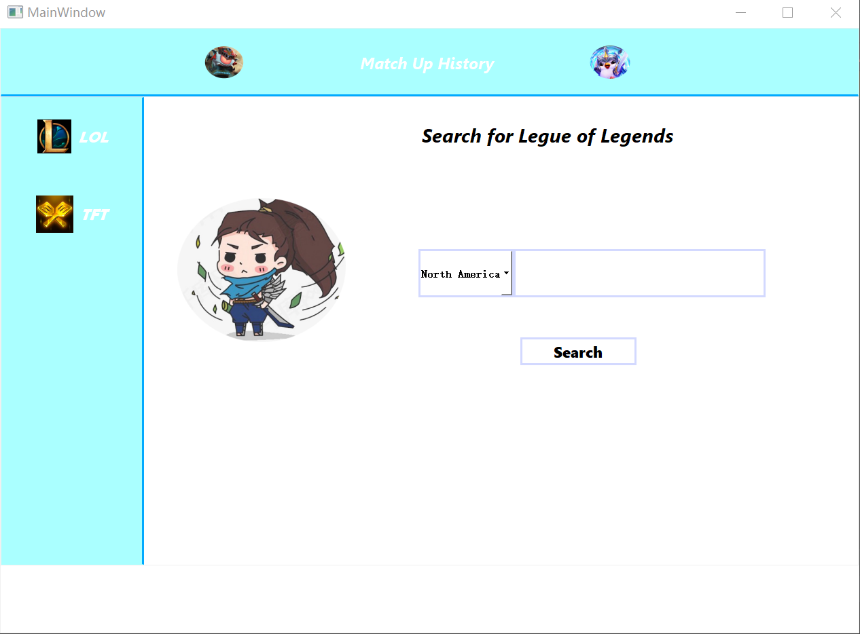

1. Notice that there are LOL and TFT searching options in the left frame, click them to switch between the two.

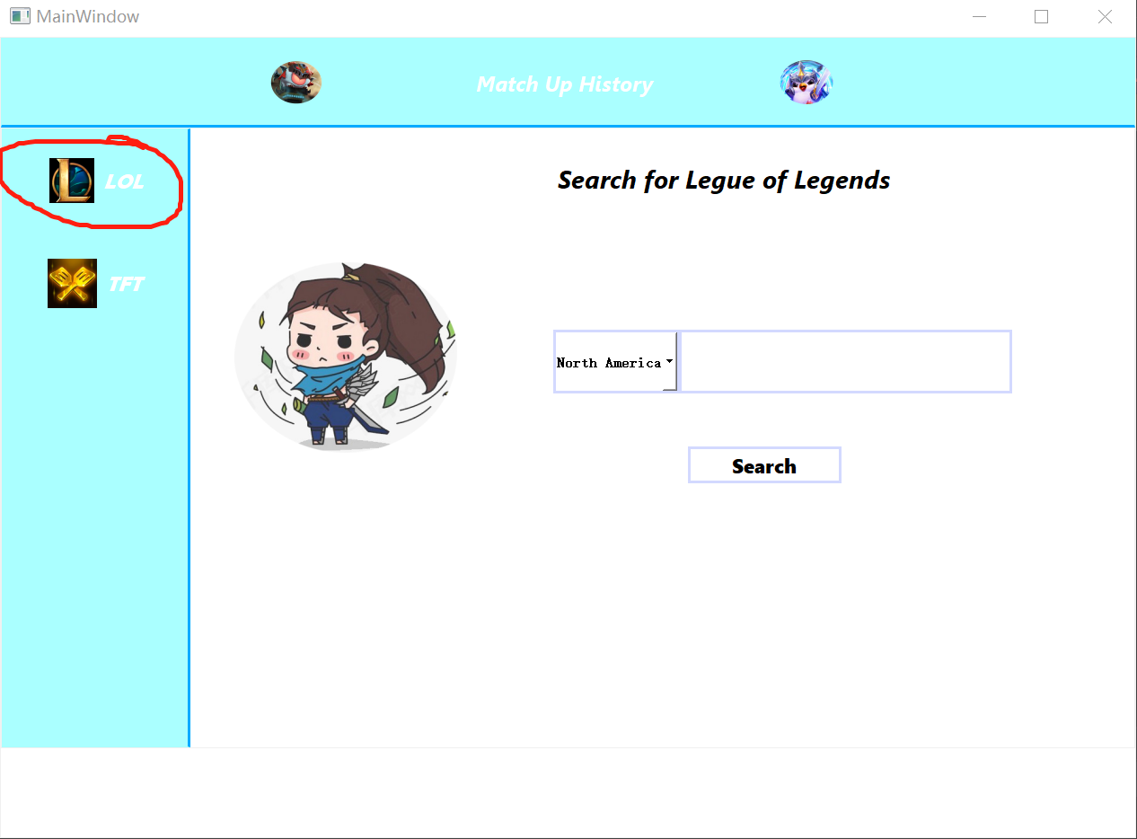

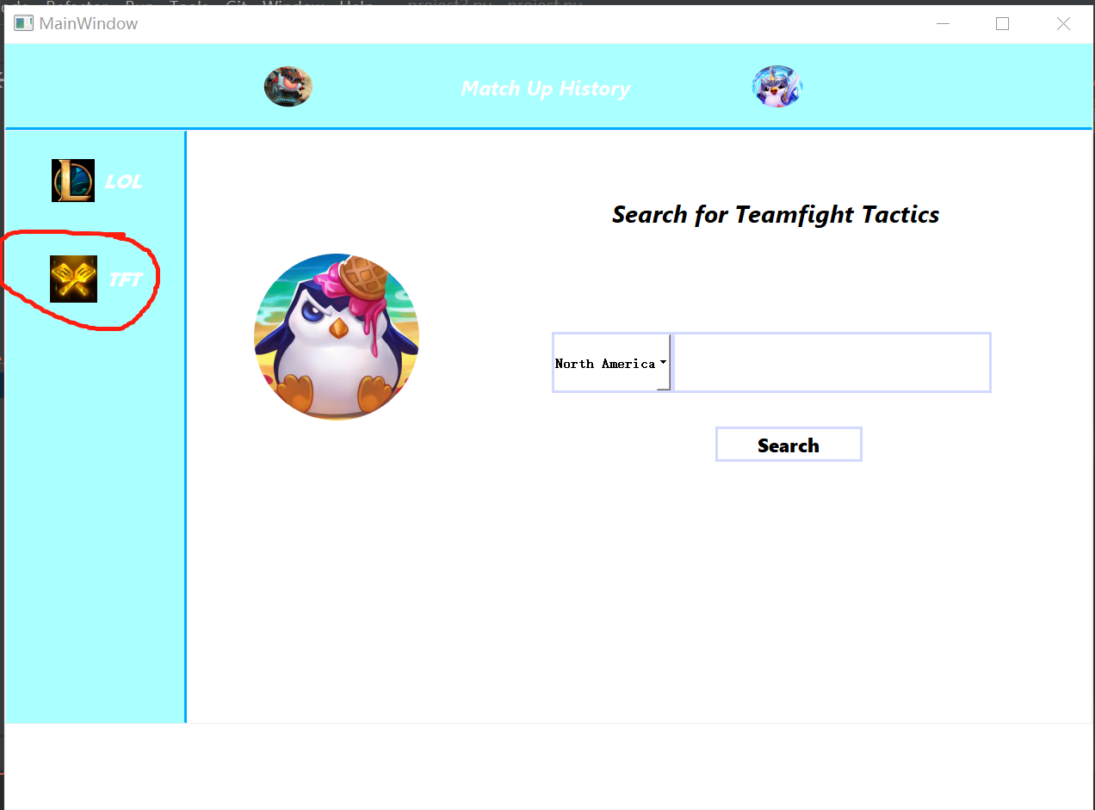

1. In the middle, there’s a search box with a drop-down button on the left(both LOL and TFT). This is the game service region where you want to search for the player id (e.g. North America, Korea), click on it and there are many options to choose from.

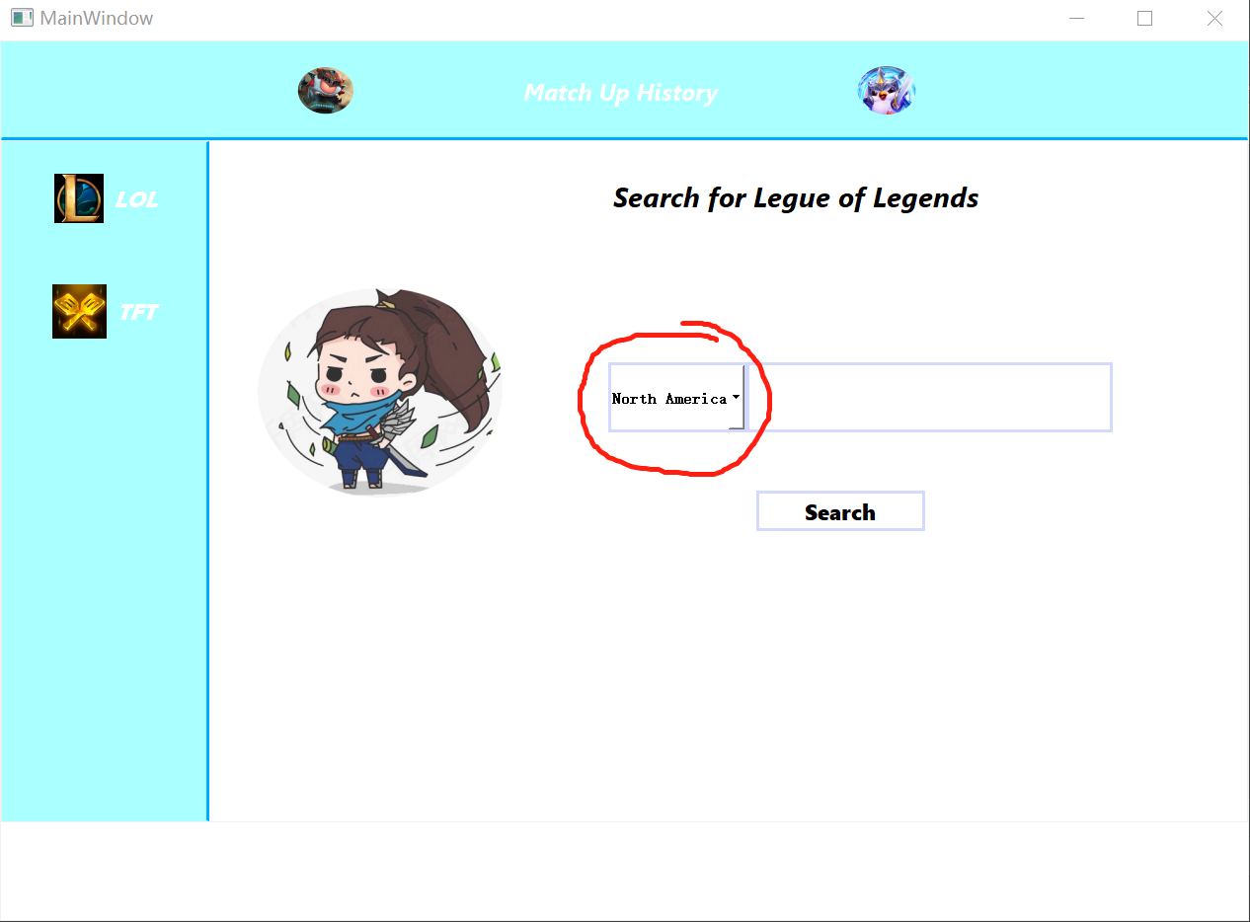

1. Type the player’s id(name) in the search bar(Note: The input name id needs to be accurate, otherwise there may be search errors or other player’s data might be searched)

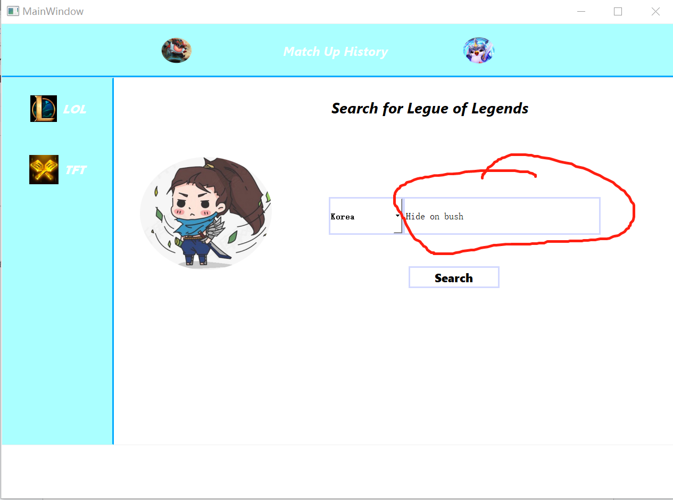

1. Then click on the search button below.

1. For LOL search page, the result page will be as below, similar to op.gg.

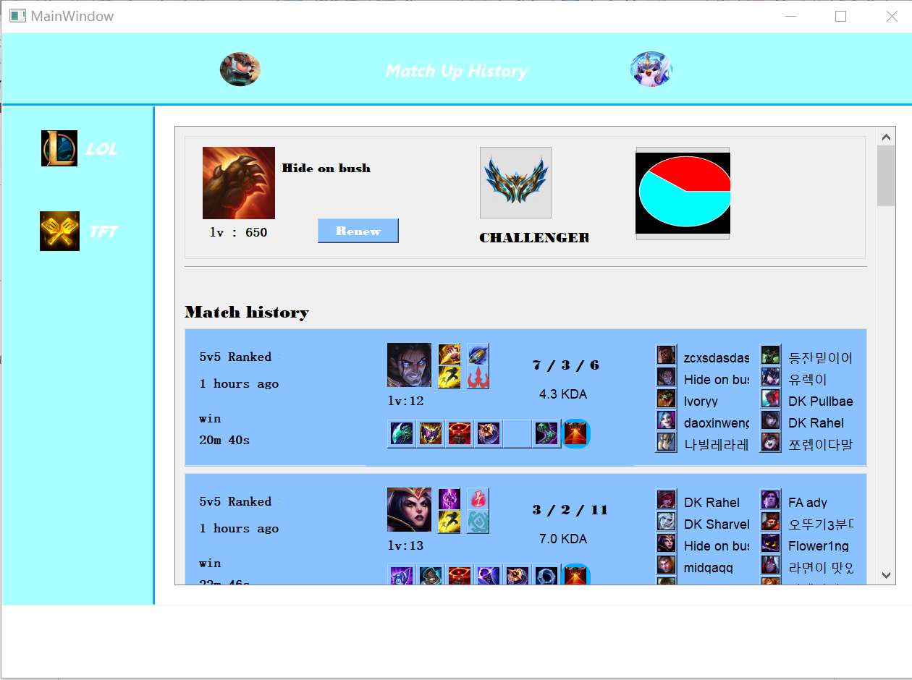

1. The first line from top to bottom is the display of player information (name, level, rank, winning rate graph). Below it is the latest game match histories. Users can drag down through the drop-down button on the right to view more game information. Also, the “renew” button can be clicked to get the latest match histories.

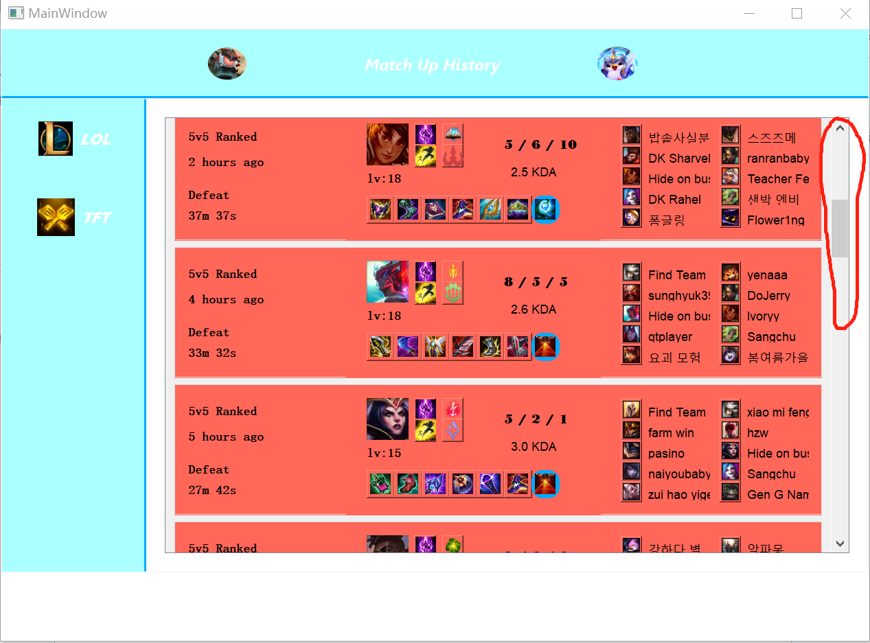

1. When you drag to the bottom of the page, there’s a “ View more history” button, click on it and the page will generate more game history.

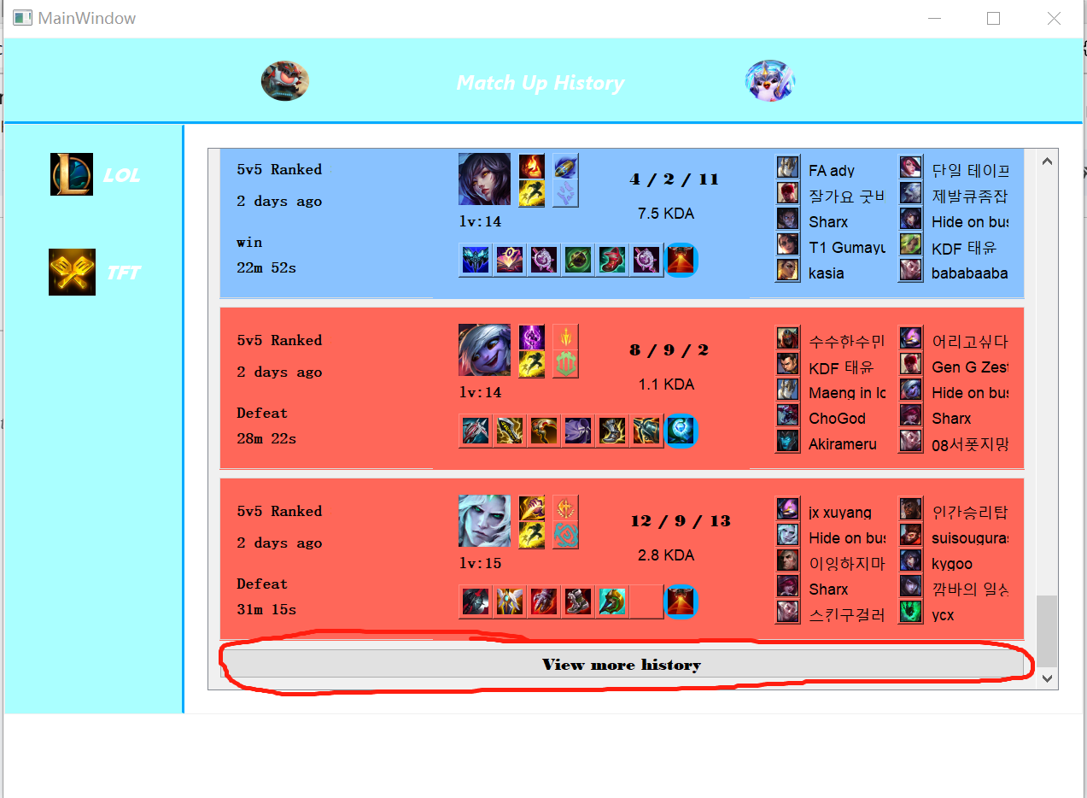

1. For TFT page, the result page will be as below, similar to LOL page.

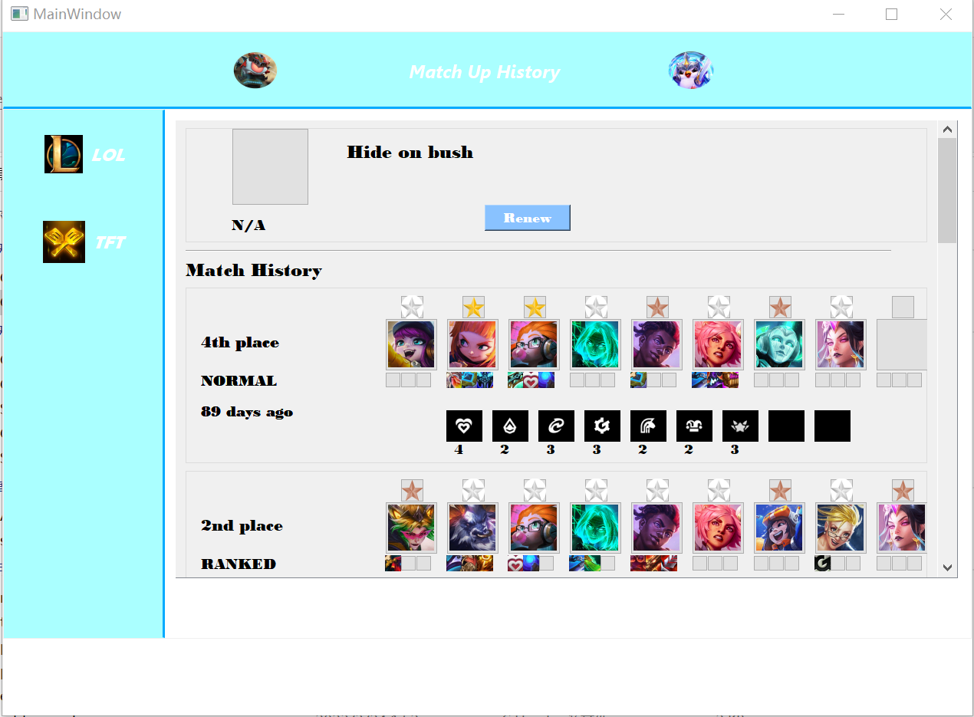

1. The first line from top to bottom is the display of player information (name, rank), if no rank in this game edition then there is no rank graph and N/A. Our program will only show matches that are in the current and last version of TFT. Also, if no more than 20 game histories can be searched, then there’s no “View more history” at the bottom of the page. Note : the gold star means 3 star level, silver is 2 star level and bronze is 1 star level.

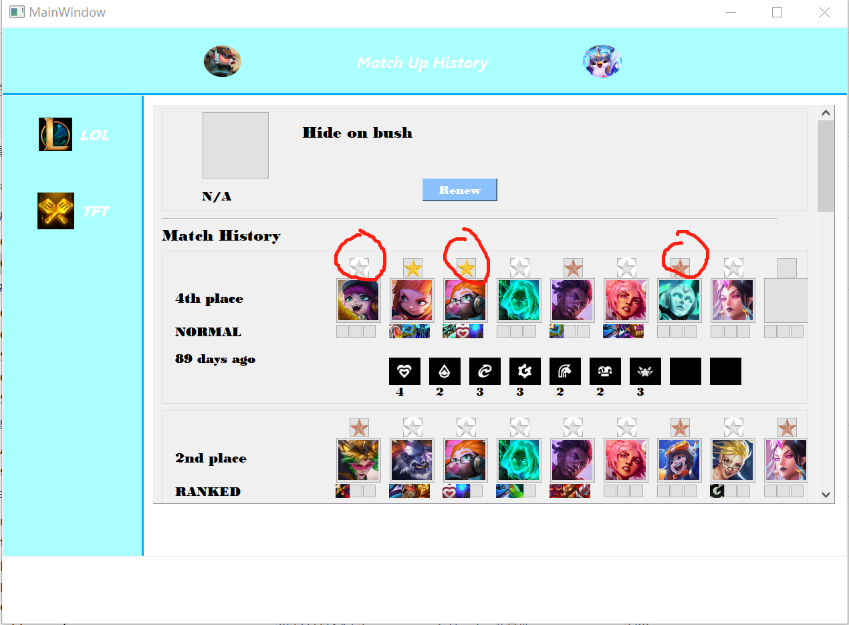

**Issue Guide**

* When searching for the wrong name, a red message will appear.

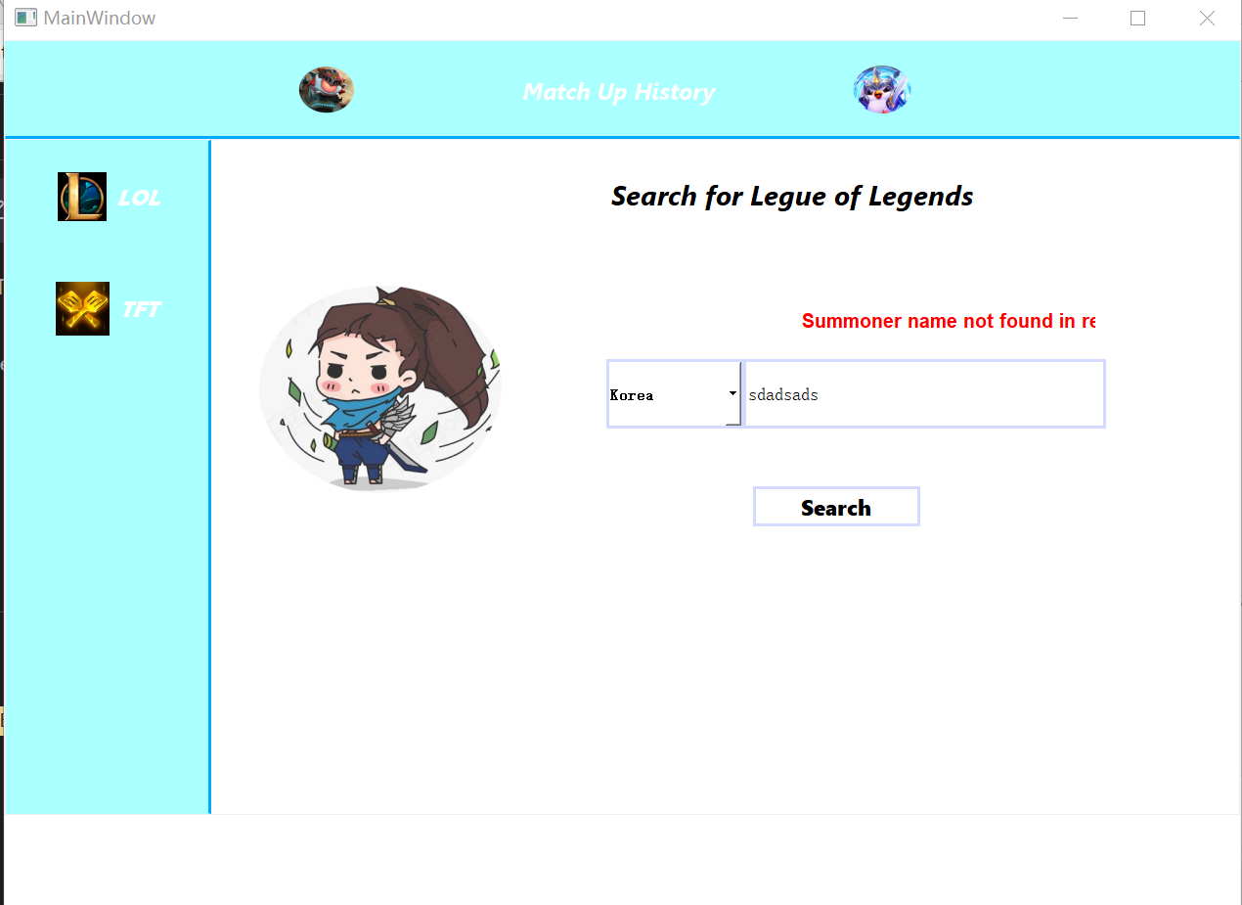

* Because multithreading is not implemented in this project(technical reason), when user clicks on “search” button(LOL and TFT page), “renew” button and “View more history” button, since the history is dynamically generated, it needs to wait for 10~20 seconds for generating, and the main menu will freeze when processing.

**Contact information**

Ruihao Zhang rzhang04@syr.edu

Jing Liu jliu83@syr.edu